EE 603

SPECTRAL ESTIMATION

TAKE HOME EXAM

e1124346
Salim SIRTKAYA

01 November 2004
TABLE of CONTENTS
General Information about the report 3
Exercise C2.17: Zero Padding Effects on Periodogram Estimators 3
Exercise C2.19: Bias and Variance Properties of the Periodogram Spectral Estimate 6
Bias Properties (a) 6
Bias Properties (b) 7
Bias Properties (c) 9
Bias Properties (d) 10
Variance Properties (a) 12

General Information about the report
In this report you can find the solutions to the exercises given in ‘INTRODUCTION to SPECTRAL ANALYSIS’ book. These exercises are:
- Exercise C2.17 :Zero Padding Effects on Periodogram Estimators
- Exercise C2.19 :Bias and Variance Properties of the Periodogram Spectral Estimator (except part e in Bias Properties)
- Exercise C2.20 :Refined Methods: Variance-Resolution Tradeoff (except part c both in Broadband and Narrowband ARMA processes)
The algorithms are implemented in .MATLAB 6.0 . The m-files of the implementations are given at the Appendix. Some commonly used Matlab functions (fft, ifft etc.) are used throughout the implementations. Other than this, all the implementations are written by Salim SIRTKAYA.
The theorethical discussions about the figures and subjects are ..

Exercise C2.17: Zero Padding Effects on Periodogram Estimators
The sequence under concern is:
y[n] = 10sin(0.2*2πn+Φ₁) + 5sin((0.2+1/N) 2πn+Φ₂) + e[n]
e[n]: White Gaussian Noise with variance ; 1 Φ₁= Φ₂=0 , N=64
Spectrum of y[n] is given as:
Φ(w) = 50π[δ(w-0.2*2π) + δ(w+0.2*2 π)] + 12.5π[δ(w-(0.2+1/N)*2π) + δ(w+(0.2+1/N)*2 π)] + 1

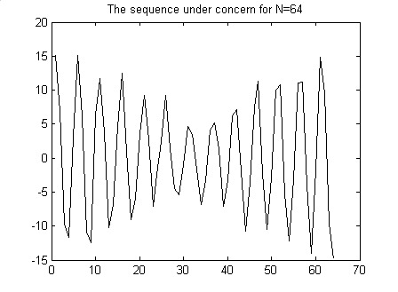
Figure 1 The original sequence of Ex 2.17
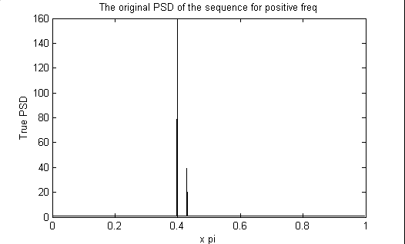
Figure 2 True power spectrum of the sequence in Ex 2.17
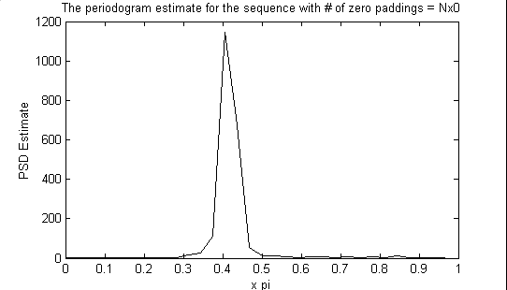
Figure 3 Periodogram PSD estimate for no zero padding
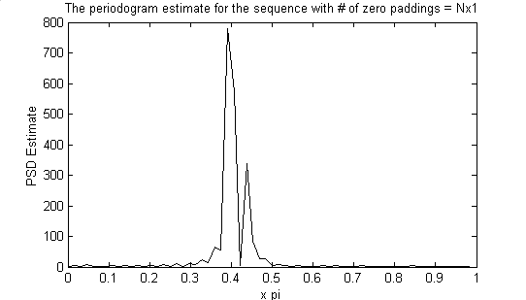
Figure 4 Periodogram PSD estimate with N zero padding
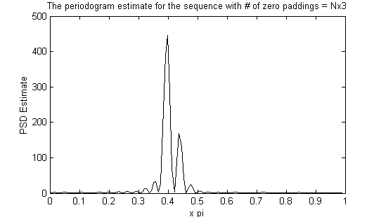
Figure 5 Periodogram PSD estimate with 3N zero padding
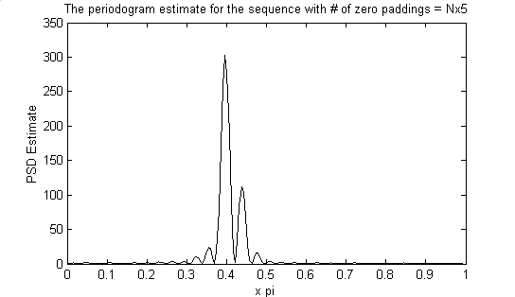
Figure 6 Periodogram PSD estimate with 5N zero padding
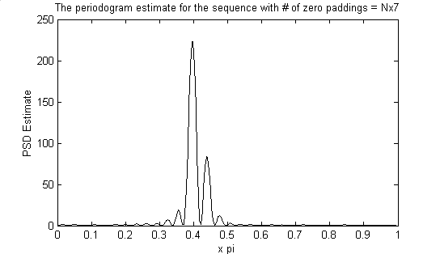
Figure 7 Periodogram PSD estimate with 7N zero padding
Comments:
- The major difference between the five spectral estimates (without zero padding, zero padding N, 3N, 5N, 7N) is the amount of power/freq. As the number of zero padding increases the power/freq decreases. This is due to the fact that, we are dividing the total power to the number of samples. Zero padding increases the number of samples but it does not affect the total power of the sequence.
- The first periodogram does not give a good description because it is estimated using 64 point fft. Therefore, the resolution of the fft process is 2pi/64=0.0982. Therefore the estimate cannot describe frequencies below 2*0.0982 (from Nyquist). However the separation between the spectral peaks of the signal is exactly 0.0982. Therefore the periodogram for N=64 cannot resolve this separation.
- It is observed that there is no significant change in the spectral resolution when the number of padded zeros increases.

Exercise C2.19: Bias and Variance Properties of the Periodogram Spectral Estimate

Bias Properties (a)
Figure 8 shows the true spectrum of the random process y[n] described in “Exercise 2.19 Bias Properties”. The true spectrum is computed by rearranging H(q) as B(q)/A(q) and then replacing q terms with e^{jw}. Then the true PSD can be computed as |B(w)/A(w) |² .
The coefficients of the filter are as follows:
a(1)=1;a(2)=1.775668;a(3)=2.672284;a(4)=1.740332;a(5)=0.960596;
b(1)=4;b(2)=7.030929;b(3)=10.473195;b(4)=6.750381;b(5)=3.687136;

The number of points used to represent the PSD is 4096.
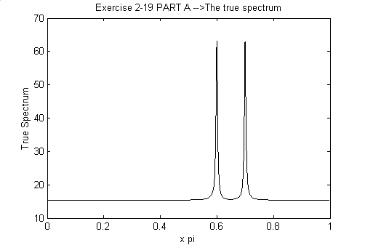
Figure 8 The true PSD of the sequence of Ex2.19 (Bias Properties)
Figure 9 shows the Autocorrelation Sequence. ACS is computed using the inverse fourier transform of the true 4096 point PSD. The autocorrelation decays rapidly as the lag increases.
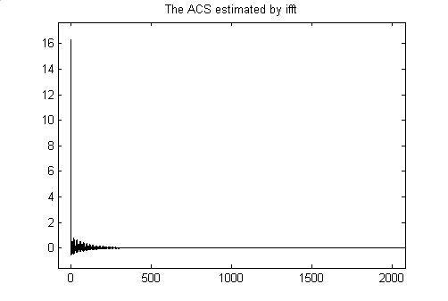
Figure 9 ACS computed by ifft of true PSD

Bias Properties (b)
Figure 10 shows 4096 point fft of the ‘Bartlett Window’ for positive frequencies. The number of window points is equal to 64.
Figure 11 shows the periodogram estimate according to equation 2.4.8 (Convolution of True PSD and Fourier Transform of Bartlett Window).
It is observed that the spectral peaks in Figure 11 is wider than the peaks in original PSD. This due to the smearing effect of the windowing process. The resolution limit of the Bartlett Window in this example is theoretically 2xpi/64 = 0.0313 x pi. The distance between the peaks of the PSD is 0.1xpi. Therefore the estimator can resolve the two peaks. However the width of the peaks is smaller than this limit. Therefore, the peaks get wider and the PSD estimate is smeared.
This wide mainlobe of the Bartlett window will decrease the resolution of the periodogram estimator.

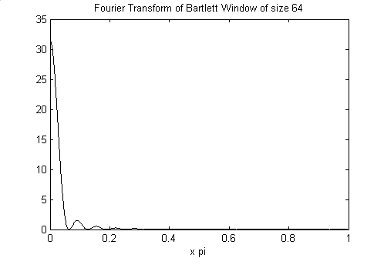
Figure 10 Fourier Transform of the Bartlett Window for positive freq. N=64
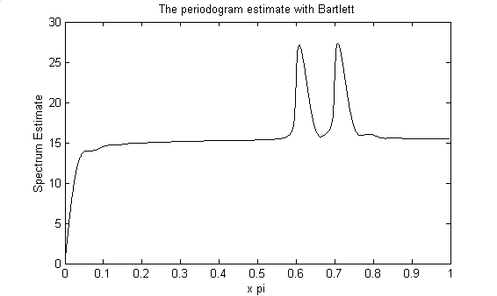
Figure 11 True PSD convolved with DTFT of Bartlett window (Equation 2.4.8)

Bias Properties (c)
Figure 12 shows the periodogram estimate for 10 realizat,ions of the random process for N=64. Figure 13 shows the average periodogram estimate of 50 realizations. Figure 14 shows the periodogram estimate with bartlett for N=64. Figure 14 is given for comparison.
From Figure 12 it can be easily seen that the periodogram estimate has a huge variance.
By averaging the estimates the variance is decreased. We theoretically know that as the number of realizations increase the average periodogram will be more stable concerning the variance.
Comparing the average estimate to Figure 14, although the two peaks are visible we can say that the variance is still high.

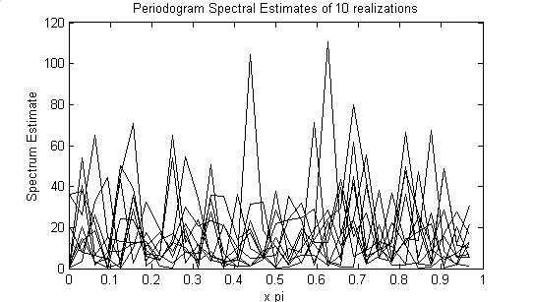
Figure 12 Periodogram Spectral Estimates for 10 realizations for N=64

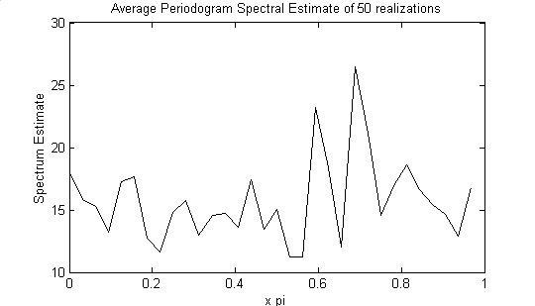
Figure 13 The average Periodogram spectral Estimate of 50 realizations for N=64
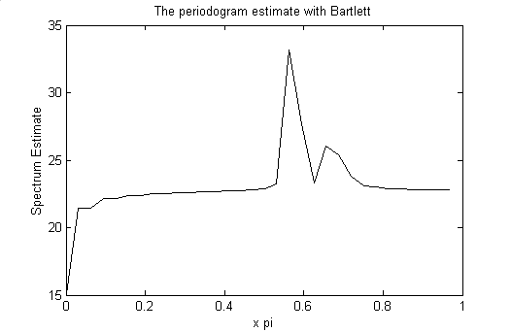
Figure 14 Periodogram Estiate in part b for N=64

Bias Properties (d)
The number of data samples is 256, therefore the bartlett window size is 256. The fft points are chosen as 256*8 to have better resolution in illustration.
Please note that in the book and in the lectures N point bartlett windows actually have 2N points because the function is two sided. For this window the resolution limit was 1/N. In MATLAB implementations when we say N point BT window it exactly has N points. Therefore for this window the resolution limit is 2/N.
When we use a BT window os size 256, the resolution limit is 2*2*pi/256=0.0156*pi radians. The seperation between the spectral peaks is 2*pi*alfa.
2*pi*alfa=0.0156*pi ==> alfa = 0.0078.
This is a theoretical value. In the implementation I take alfa as 0.008 and observed that the estimator can resolve the spectral peaks for most realizations. Instead of giving individual estimates, the average estimate of the 50 realizations is given to give a true understanding about the resolution.
shows the true PSD of the random process when alfa=0.008.
Figure 16 shows the average periodogram estimate of 50 realizations of the random process.
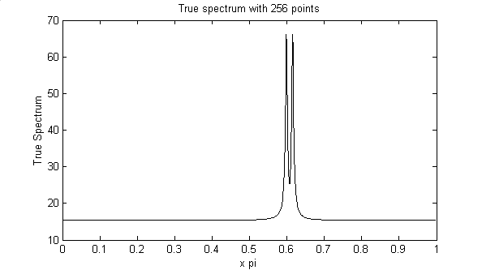
Figure 15 True Spectrum with N=256, number of fft points = N*16, alfa = 0.008
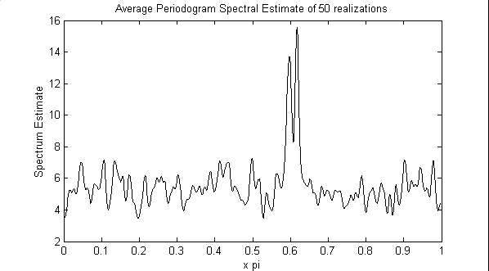
Figure 16 Average Periodogram Spectral Estimate of 50 realizations

Variance Properties (a)
Figure 17 shows the true spectrum of the random process y[n] described in “Exercise 2.19 variance properties”. The true spectrum is computed as |B(w)/A(w) |² .
The coefficients of the filter are as follows:
a(1)=1;a(2)=-1.3817;a(3)=1.5632;a(4)=-0.8843;a(5)=0.4096;
b(1)=1;b(2)=0.3544;b(3)=0.3508;b(4)=0.1736;b(5)=0.2401;
The number of points used to represent the PSD is 4096.
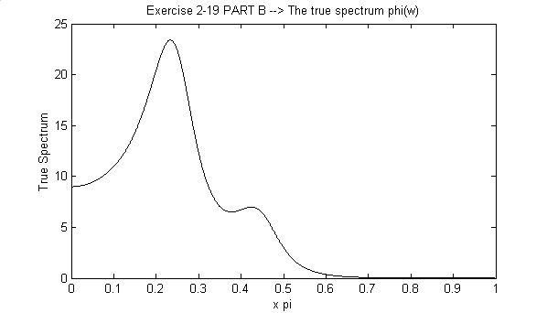
Figure 17 The true PSD of the sequence of Ex2.19 (Variance Properties)

Variance Properties (b)
Figure 18, Figure 19 and Figure 20 show the mean periodogram estimates for N=64, N=256 and N=1024. Tin the figures, the mean estimates are shown with blue line. Within each figure, the mean-std estimate is shown with green line and mean+std estimate is shown with red line. From these figures it is observed that the variance does not decrease with increasing sample number. Note that the smoothness of the first estimate is just due to the low resolution and it is just illustrative. The ±std plots give us a true understanding about the variance. Actually this is an expected results because the periodogram estimate is INCONSISTENT concerning the variance.

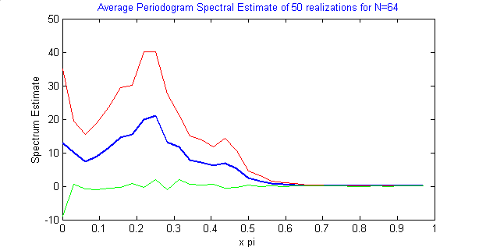
Figure 18 Blue Line : Mean Periodogram estimate for N=64
Red Line: Mean+std Periodogram estimate N=64
Green Line: Mean-std Periodogram estimate N=64
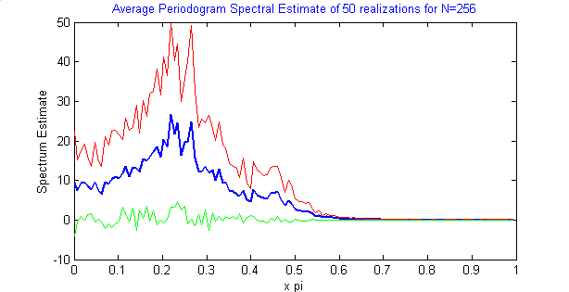
Figure 19 Blue Line : Mean Periodogram estimate for N=256
Red Line: Mean+std Periodogram estimate N=256
Green Line: Mean-std Periodogram estimate N=256
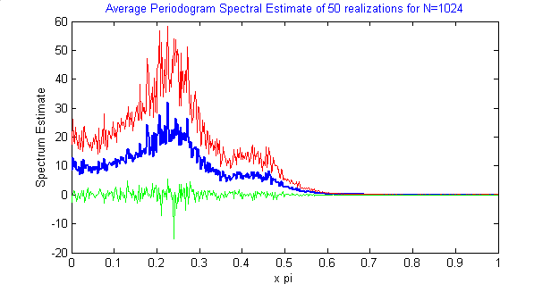
Figure 20 Blue Line : Mean Periodogram estimate for N=1024
Red Line: Mean+std Periodogram estimate N=1024
Green Line: Mean-std Periodogram estimate N=1024

